**VISUALIZATION TOOL FOR ELECTRIC VECHILE CHARGE AND RANGE ANALYSIS**

**1 INTRODUCTION**

1.1 Overview

1.2 Purpose

**2 PROBLEM DEFINITION AND DESIGN THINKING**

2.1 Empathy Map

2.2 Ideation and Brainstroming Map

**3 RESULT**

**4 ADVANTAGES AND DISADVANTAGES**

**5 APPLICATIONS**

**6 CONCLLUSION**

**7 FUTURE SCOPE**

**8 APPENDIX**

**1 INTRODUCTION**

**1.1 OVERVIEW**

A vehicle that can be powered by an electric motor that draws electricity from a battery and is capable of being charged from an external source and have an electric motor instead of an internal combustion engine.

The Electric Vehicle (EV) is not new, but it has been receiving significantly more attention in recent years. Advances in both EV analytics and battery technologies have led to increased automotive market share. However, this growth is not attributed to hardware alone. The modern mechatronic vehicle marries electrical storage and propulsion systems with electronic sensors, controls, and actuators, integrated closely with software, secure data transfer, and data analysis, to form a comprehensive transportation solution. Advances in all these areas have contributed to the overall rise of EV’s, but the common thread that runs through all these elements is data analytics.

The new EV’s are combined Electrical storage and propulsion systems with electronic sensors, controls, and actuators, integrated closely with software, secure data transfer to form a comprehensive transportation solution.

**1.2 PURPOSE**

With the explosive growth in the number of electric vehicles, investigating the impact of large scale electric vehicles charging behavior has received much attention. Numerous studies have given insights into large scale electric car charging influence, Diana et al conducted a systematic literature reviews and conclude there are mainly two approaches, environmental analyses as well as in travel demand analysis.

Using conventional cars data to simulate electric vehicles (EVs) use patterns, Michele et al use GPS tracer to collect gasoline vehicle travel information, and simulate the influence of electric vehicle charging behavior on power grid .

Moreover, this study also uses heat map to visualize the charging demand on map. Darabi and Ferdowsi use US National travel survey to estimate demand curve.

However, some researchers point out the scenarios for using EV is different from conventional cars.

For this purpose, we conducted online survey which could collect geographic information about where users charge their vehicles. We simulate real-time demand curve, and then estimated the influence of electric vehicles charging in space domain using a model based on heat map.

**2 PROBLEM DEFINITION AND DESIGN THINKING**

**2.1 Empathy Map**

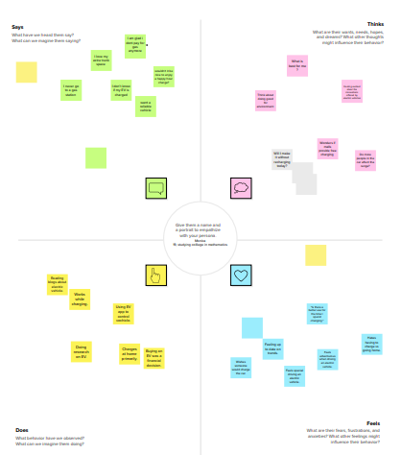

**2.2 Ideation and Brainstroming Map**



**3 RESULT**

**DASHBOARD**

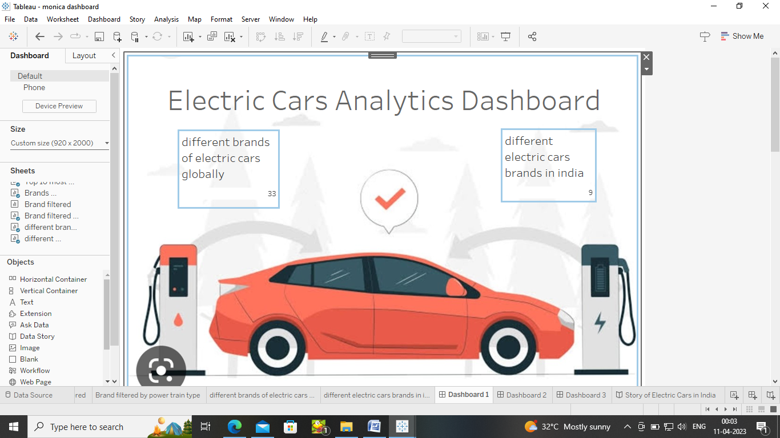

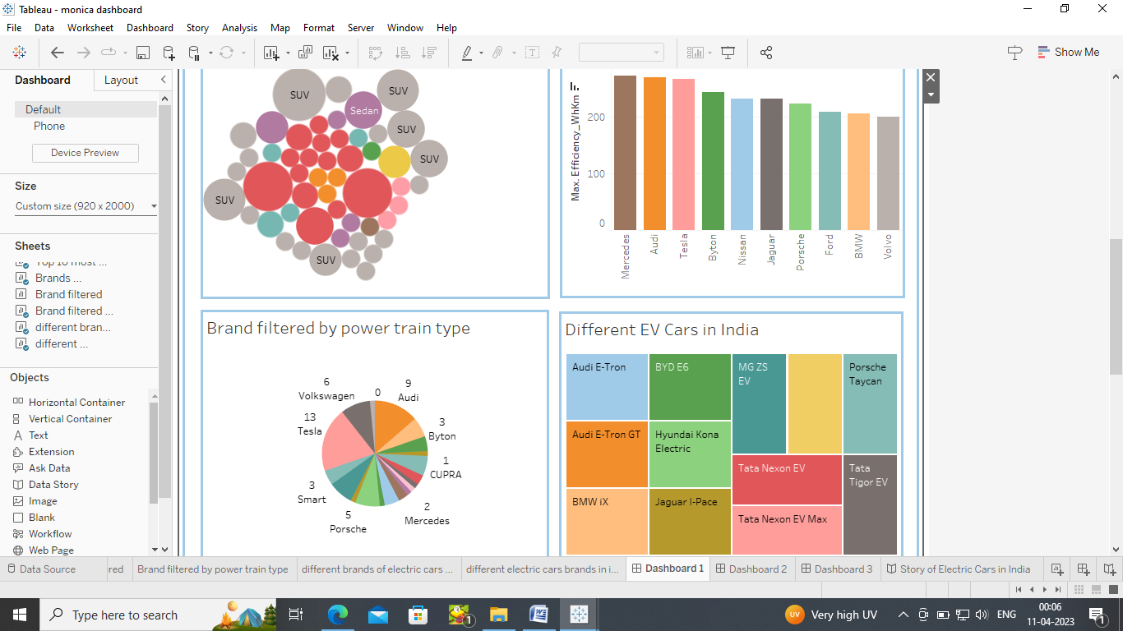





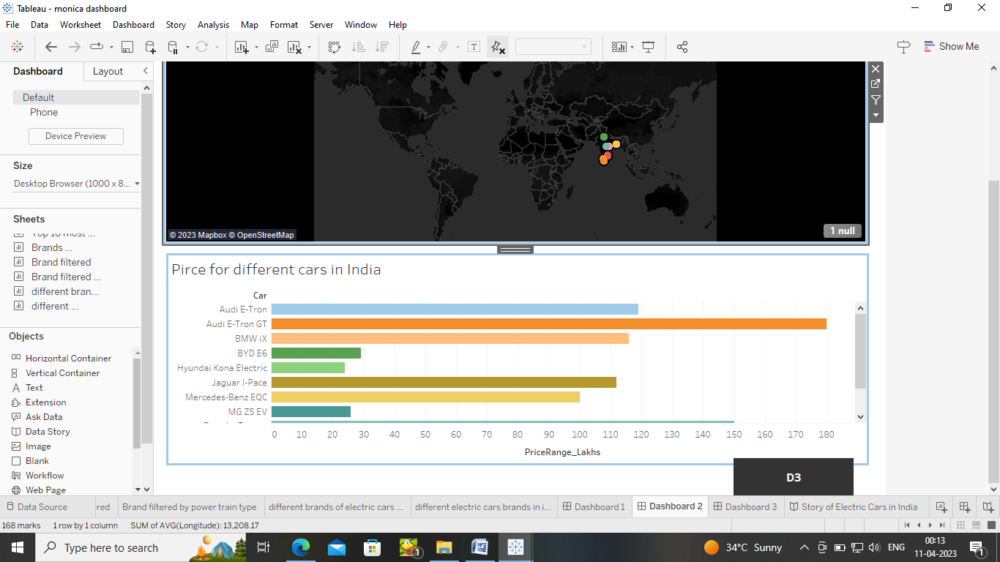





FINAL DASHBOARD OUTPUT ON TABLEAU PUBLIC

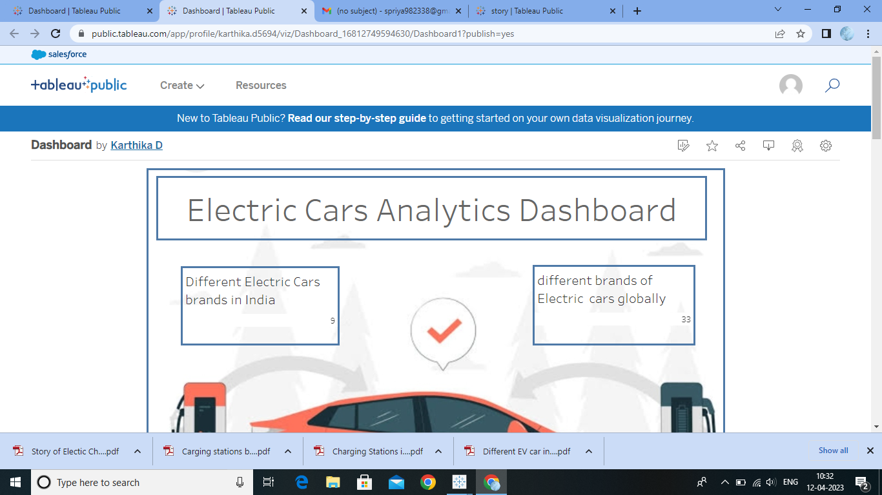



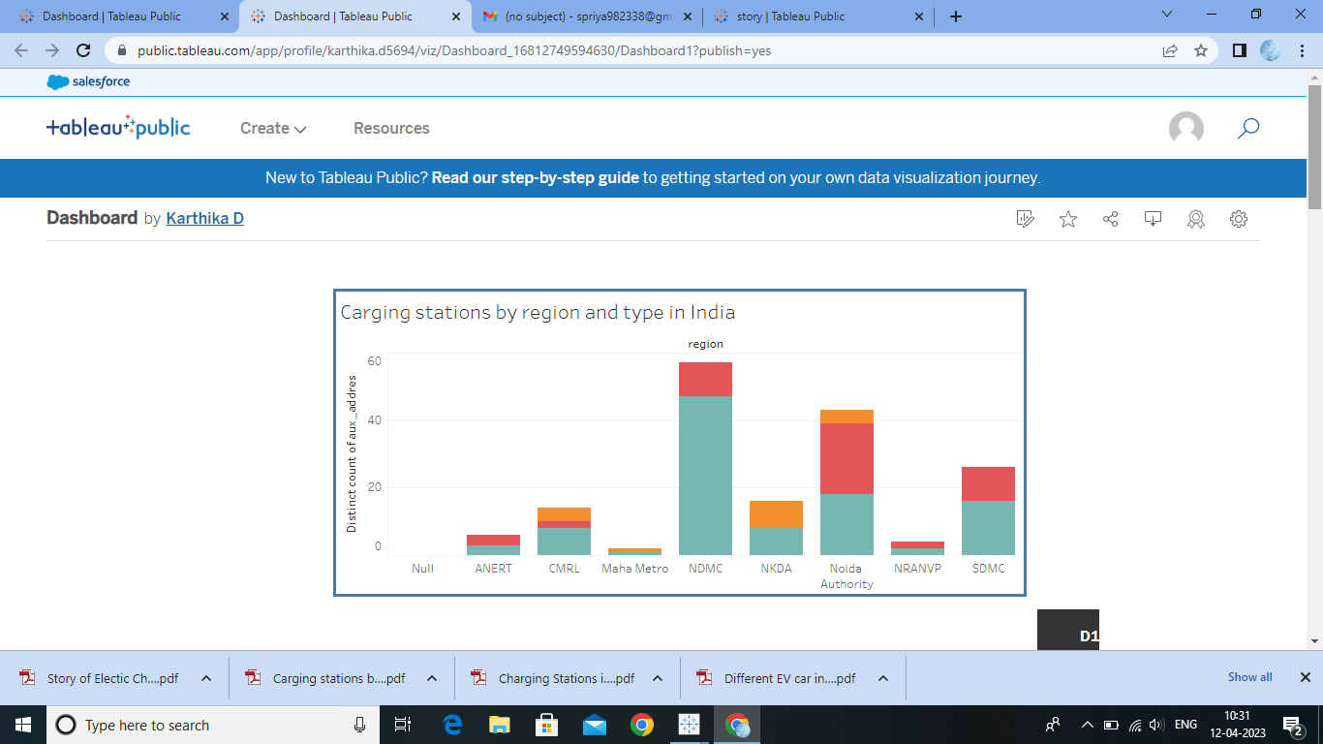

**STORY**

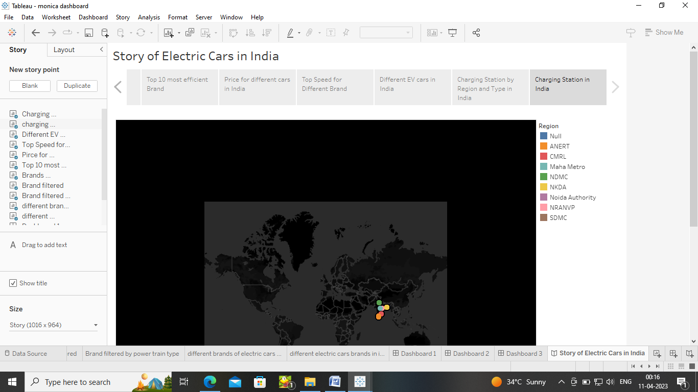

**FINAL STORY OUTPUT ON TABLEAU PUBLIC**

**C:\Users\User\Pictures\Screenshots\Screenshot (33).png**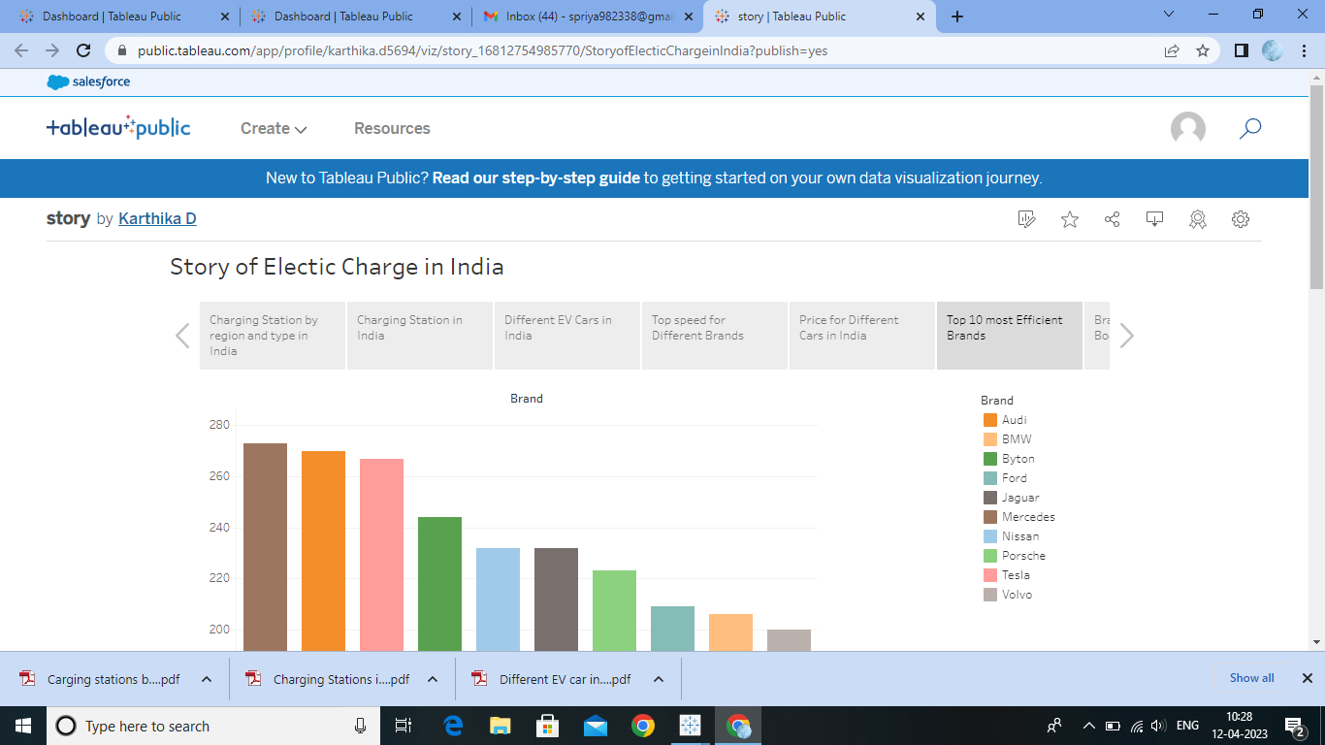

**4 ADVANTAGES & DISADVANTAGES**

**ADVANTAGE**

**Eco-friendly:**Because electric vehicles do not utilize fuel for combustion, there are no emissions or gas exhaust. Vehicles that run on fossil fuels contribute significantly to hazardous gas accumulation in the environment, thus driving an electric car can help contribute to a cleaner environment.

**Renewable energy source:** Electric vehicles run on renewable power, whereas conventional automobiles function on the combustion of fossil fuels, which reduces the world’s fossil-fuel stocks.

**Less noise and smoother motion:** Driving an electric car is significantly smoother. Because they lack fast-moving elements, they are quieter and produce less noise.

**Cost-effective:** Electricity is far less expensive than fuels such as gasoline and diesel, which are subject to regular price increases. When solar electricity is utilized at home, battery recharging is cost-effective.

**Low maintenance:** Because electric cars have fewer moving components, wear and tear is reduced when compared to traditional auto parts. Repairs are also simpler and less expensive than combustion engines.

**Government support:** Governments throughout the world have granted tax breaks to encourage people to drive electric vehicles as part of a green program.

**High initial cost:**Electric vehicles continue to be quite expensive, and many buyers believe they are not as inexpensive as traditional automobiles.

**DISADVANTAGE**

**High initial cost:**Electric vehicles continue to be quite expensive, and many buyers believe they are not as inexpensive as traditional automobiles

**Charging station limitations:** People who need to travel long distances are concerned about finding adequate charging stations in the middle of their journey, which are not always accessible.

**Recharging takes time:** Unlike conventional automobiles, which require only a few minutes to replenish their gas tanks, charging an electric vehicle takes many hours.

**Limited options:**Currently, there aren’t many electric car models to pick from in terms of appearance, style, or customized variations.

**Less driving range:**When compared to conventional automobiles, electric vehicles have a shorter driving range. Electric cars can be convenient for short-distance travel but are inconvenient for long-distance travel.

**5 APPLICATIONS**

Transport is a fundamental requirement of modern life, but the traditional combustion engine is quickly becoming outdated. Petrol or diesel vehicles are highly polluting and are being quickly replaced by fully electric vehicles. Fully electric vehicles (EV) have zero tailpipe emissions and are much better for the environment. The electric vehicle revolution is here, and you can be part of it.

**Low running cost**:

The running cost of an electric vehicle is much lower than an equivalent petrol or diesel vehicle. Electric vehicles use electricity to charge their batteries instead of using fossil fuels like petrol or diesel. Electric vehicles are more efficient, and that combined with the electricity cost means that charging an electric vehicle is cheaper than filling petrol or diesel for your travel requirements. Using renewable energy sources can make the use of electric vehicles more eco-friendly. The electricity cost can be reduced further if charging is done with the help of renewable energy sources installed at home, such as solar panels.

**Low maintenence cost:**

Electric vehicles have very low maintenance costs because they don’t have as many moving parts as an internal combustion vehicle. The servicing requirements for electric vehicles are lesser than the conventional petrol or diesel vehicles. Therefore, the yearly cost of running an electric vehicle is significantly low.

**Zero Tailpipe emission:**

 Driving an electric vehicle can help you reduce your carbon footprint because there will be zero tailpipe emissions. You can reduce the environmental impact of charging your vehicle further by choosing renewable energy options for home electricity.

**Tax and financial benefits:**

Registration fees and road tax on purchasing electric vehicles are lesser than petrol or diesel vehicles. There are multiple policies and incentives offered by the government depending on which state you are in.

**Electic Vechicles are easy to drive and quiet**

Electric vehicles don’t have gears and are very convenient to drive. There are no complicated controls, just accelerate, brake, and steer. When you want to charge your vehicle, just plug it in to a home or public charger. Electric vehicles are also quiet, so they reduce noise pollution that traditional vehicles contribute to.

**No noise pollution**

Electric vehicles have the silent functioning capability as there is no engine under the hood. No engine means no noise. The electric motor functions so silently that you need to peek into your instrument panel to check if it is ON. Electric vehicles are so silent that manufacturers have to add false sounds in order to make them safe for pedestrians

**Convenience of charging at home**

Imagine being at a busy fuel station during peak hours, and you are getting late to reach your workplace. These problems can easily be overcome with an electric vehicle. Simply plug your vehicle in at your home charger for 4-5 hours before you plan to go. If you are able to get a charger where you park at home, it is very convenient to plan your journeys in advance. What if you forget to plug in your machine someday? Then you can easily take the help of fast chargers or even battery swapping services if you are on a two-wheeler on the road..

**6 CONCLUSION**

Electric vehicles are the wave of the future! Manufacturing businesses are putting more effort into transitioning from traditional automobiles to electric vehicles. There are several advantages to owning an electric car with the appropriate level of functionality and infrastructure.

**7 FUTURE SCOPE**

India offers the world’s largest untapped EV market, especially in the two-wheeler segment. With several automakers rolling out EV vehicles at a rapid pace, the penetration of these vehicles has increased significantly in the past few years. As per a recent study, electric vehicles (EVs) market is expected to be worth around at least ₹475 billion by 2025. The penetration of electric two-wheelers is projected to reach up to 15% by 2025 from 1% currently.

As business activities gain pace and the Indian economy rebounds its way in 2022, the auto industry is set to enter a new phase of growth, innovation and investment. However, the road to the future of EV is battling various challenges. While the government is aggressively promoting EV adoption in India, the inadequate infrastructure, lack of high performing EVs and high upfront cost is causing a major hindrance for its mass adoption.

**8 APPENDIX**

Source code - nill